10.2.U5 Chi-squared tests are used to determine whether the difference between an observed and expected frequency distribution is statistically significant. AND 10.2.S3 Use of a chi-squared test on data from dihybrid crosses.

- In corn ears there are four main phenotypes: purple and smooth, purple and shrunken, yellow and smooth, yellow and shrunken. You will examine an ear of corn and determine the type of cross and genes responsible for the coloration and texture of the corn kernels and also whether the corn kernel colour and texture follows the expected pattern of dihybrid inheritance. Use the image below to take the sample for your investigation.
(activity based on: http://www.biologycorner.com/worksheets/corn_chi.html)

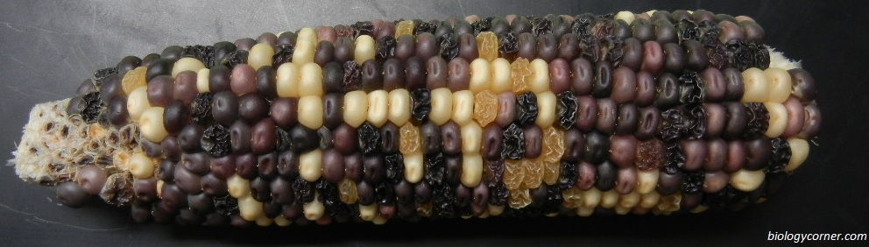

  - Select five rows on the corn ear to sample for colouration (purple or yellow) and texture (smooth or shrunken) and record your findings in the tables below. The sample used must be the same for both characteristics.

 | Kernel Colouration
 | Number of Kernels | Kernel Percentage (%)
Purple
Yellow
Total
 | Kernel Texture
 | Number of Kernels | Kernel Percentage (%)
Smooth
Shrunken
Total

  - Deduce the probable colouration phenotypes of the parents.

  - Deduce the probable texture phenotypes of the parents.
  - Assuming that purple (P) is dominant to yellow (p) and smooth (S) is dominant to shrunken (s) complete a dihybrid cross between two heterozygous parents and calculate the expected phenotype ratio.

Phenotype
Ratio

  - Using the same five rows as earlier count the phenotypes present and calculate the percentage frequency of each.
 | Observed phenotype frequency
 | Number of Kernels | Kernel Percentage (%)
Purple and Smooth
Purple and shrunken
yellow and Smooth
yellow and shrunken
Total

Did you obtain a 9:3:3:1 ratio? To determine if the deviations between expected frequencies and the observed data are due to natural variation or whether the difference is statistically significant use a chi-squared test. Calculate the chi-squared value using the table below:
 | Chi-squared calculations
 | Expected  (number of kernels) | Observed  (number of kernels) | (Observed – Expected)²  Expected
Purple and Smooth | total x 9/16 =
Purple and shrunken | total x 3/16 =
yellow and Smooth | total x 3/16 =
yellow and shrunken | total x 1/16 =
Total |  |  | Chi-squared =  sum of (O-E)²/E

  - Calculate the degrees of freedom.
df = Number of classes (phenotypes) – 1 =
df | critical values at 5%
1 | 3.84
2 | 5.99
3 | 7.82
4 | 9.49
5 | 11.07
  - Is the (expected) theory of dihybrid corn kernel colouration and texture inheritance supported by the (observed) data?
(is Chi-square value < critical value)

10.2.U3 Variation can be discrete or continuous. AND 10.2.U4 The phenotypes of polygenic characteristics tend to show continuous variation.

- Polygenic inheritance gives rise to continuous variation.
  - Define polygenic inheritance.

  - Distinguish between polygenic inheritance and multiple alleles.

  - List one human and one plant example of polygenic inheritance.

  - Define contributing allele.

  - Explain how polygenic inheritance gives rise to continuous variation within a population using skin colour as an example.

- Assume that two genes (A and B) are responsible for inheritance of skin colour, with two alleles each and that they are unlinked. The dominant alleles code for melanin production.
  - Calculate the number of possible genotypes.

  - Apply the possible genotypes to the range of phenotypes below:
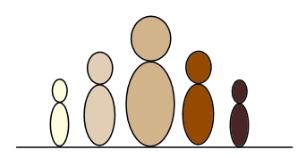
aabb | Aabb

  - Using a punnet grid, explain why it is possible for children to have skin which is darker or lighter than both parents.

Mother genotype: Father genotype:

Outcome and explanation:

- A characteristic is controlled by two unlinked genes with two alleles. Deduce the number of possible genotypes and phenotypes.

- A characteristic is controlled by three genes with two alleles each. Calculate the number of genotypes possible in a cross between a homozygous recessive father and a homozygous dominant mother.

10.2.A3 Polygenic traits such as human height may also be influenced by environmental factors.

- Most traits, including polygenetic traits such as height, maybe influenced by the environment of the organism. Complete the table to give examples of the ways in which this can happen.

Human Trait | Influencing Environment factors
Height
Skin colour

