- Define pathogen.
“An organism or virus that causes disease.” ^{(1 p. 49)}

- List some examples of illness which are pathogenic and non-pathogenic.
Pathogenic:
Non-pathogenic:

- Outline one example of an infection by each of the following types of pathogens:
Type of pathogen | BACTERIA | VIRUS | FUNGI | PROTOZOA
Example disease | Cholera
Pathogen | Vibrio cholerae
Method of transmission | Contaminated drinking water or food
Symptoms | Severe diarrhea and vomiting
Treatment | Urgent oral rehydration, antibiotics
Dangers | Death by dehydration

- Explain why antibiotics can be used to treat bacterial infections but not viruses.

Link thought: how does overuse of antibiotics lead to antibiotic resistance?
- In the space below, draw and annotate two simple line graphs to distinguish between the action of bacteriostatic and bacteriocidal antibiotics:
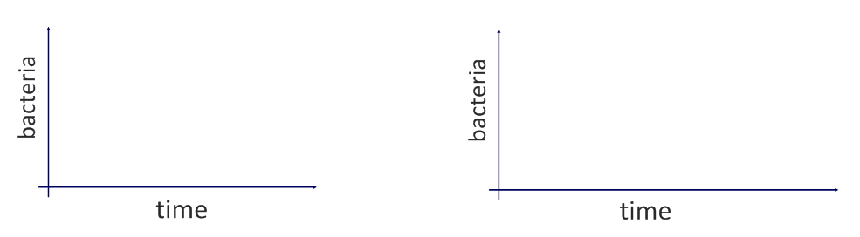
Link thought: how does overuse of antibiotics lead to antibiotic resistance?
- Outline the role of skin and mucous membranes in primary defense (acting as barriers against pathogens):
Skin is a tough barrier
Hairs, e.g. nose
Mucous, such as in nose, airways
Acidic conditions (e.g. stomach and vagina)
Lysozymes
Natural organisms

- State the functions of the following components of the blood:
Erythrocytes
Platelets
Plasma
Leukocytes (white blood cells)
Phagocytes |  |  | Lymphocytes
Macrophages |  |  | B-Cells
 |  |  | T-Cells

- Blood clotting is an example of a metabolic pathway.
Describe the process of blood clotting.

- Outline how phagocytic leukocytes ingest pathogens in the blood and body tissues.
Method of membrane transport:
How does it work?
- Distinguish between antibodies and antigens.

Antibody | A globular protein. (revise levels of protein structure)  Produced as part of the immune response.  Specific to the antigen on the pathogen – the antigen binding site is analogous to the active site of an enzyme.
Link thought: how is this important in ABO blood typing and how is that an example of codominance?
- Explain clonal selection as a basis for immunity.
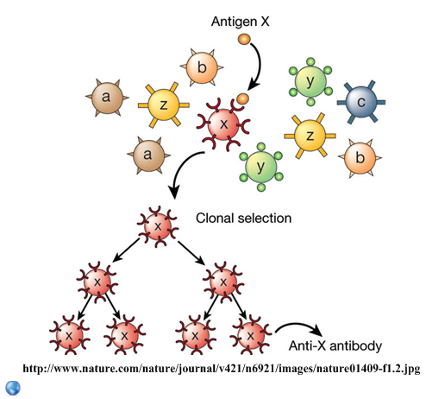 | There are many different types of lymphocytes in the immune system.
Link thought: antibodies are globular proteins produced by lymphocytes. Explain how the final antibody is produced from the genetic information in the lymphocyte nucleus, to a level of detail appropriate to your level of study.
- Briefly describe the principle of polyclonal selection.

- State the role of memory cells following an infection.
- Define active and passive immunity.
Active:
Passive:

- State examples of the following types of immunity.
Active |  | Passive
Natural | Artificial | Natural | Artificial
- Explain how antibodies are produced.
Use the following terms: pathogen, phagocyte, epitope (antigen), helper T-cell, B-cell, clone, plasma cell, antibody.
- Pathogen is ingested by a macrophage.

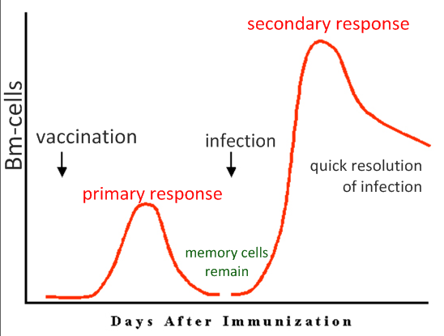
- Explain the principles of vaccination.
- Antigen is introduced to the body

- Discuss the benefits and potential dangers of vaccinations.
Benefits | Potential Dangers
Eradication of diseases, such as smallpox.

Further reading: “The Media’s MMR Hoax” http://www.badscience.net/2008/08/the-medias-mmr-hoax/
In this article, Dr Ben Goldacre debunks the dangerous myth that the MMR vaccine is linked to autism. This was a case of very poor science reporting by a poor newspaper, based on poor scientific research. The resulting panic resulted in dropping MMR vaccination uptake rates.
Ethical discussion: What are the ethical considerations of enforced vaccination programs?
- Monoclonal antibodies are produced industrially for use in medicine.
- State three uses of monoclonal antibodies
Diagnosis of condition | Pregnancy test kits, heart attack detection
Diagnosis of infection
Treatment

- Describe the industrial process of monoclonal antibody production.
Refer to B-cells, tumours and hybridomas.
- Immune response is stimulated in a lab animal
- Specific B-cells are harvested

