Blog resource: http://tinyurl.com/2fr4zh8 Click4Biology: http://tinyurl.com/26okfxo
- Define the following:
Gamete | Haploid sex cell, which fuses with another gamete in fertilization. Sperm and eggs. ⁽¹⁾
Oogenesis
Spermatogenesis
Fertilisation
Gestation

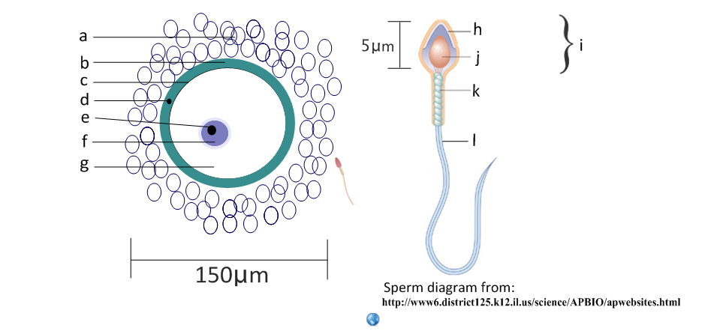
- Label the structures of the mature sperm and egg and calculate the magnification of each image.
a | follicle cells | h
b |  | i | head
c |  | j
d |  | k
e |  | l
f |  | Magnification:
g
Magnification:

- Annotate this light micrograph of testis tissue.
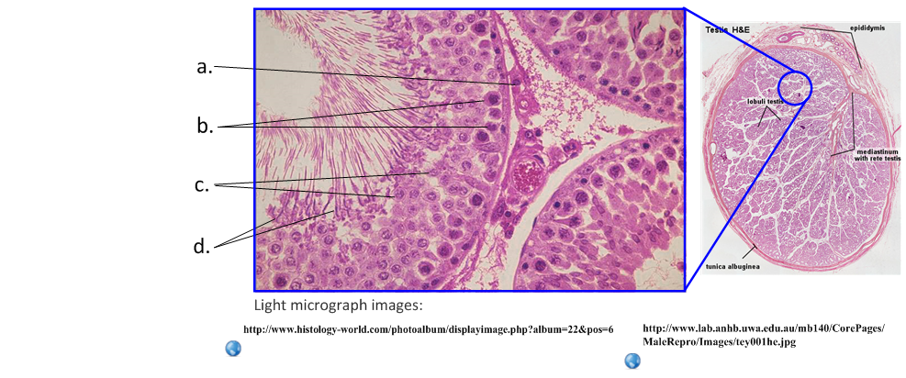
a | interstitial cells
produce testosterone.
b
c
d
State the roles of the following hormones in spermatogenesis.
Luteinizing hormone (LH)
Testosterone
Follicle stimulating hormone (FSH)
Compare spermatogenesis and oogenesis.
 | Spermatogenesis | Oogenesis
Number of gametes produced per primary cell
Formation of gametes | Constant after puberty
Number of meiotic divisions
Method of release of gametes |  | Ovulation, controlled by LH
Outline the process of spermatogenesis in the testes.

- Label and annotate these structures of the ovary.
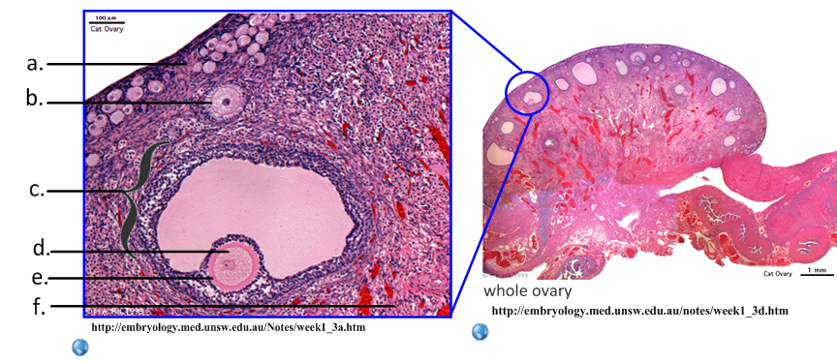
a | germinal epithelium
Constant mitosis produces primary follicles.
b
c
d
e
f
- Outline oogenesis.
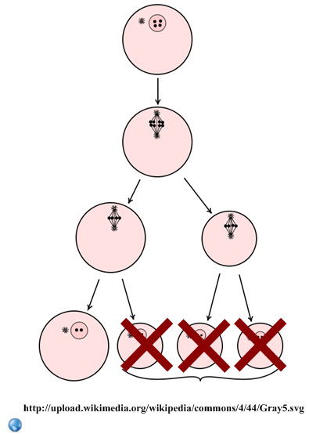

- State the role of these two hormones in the female reproductive system.
HCG:
Oxytocin:

- HCG is released early in the pregnancy if a blastocyst implants on the endometrium.
- State the origin of HCG.

- Outline two functions of HCG in early pregnancy.
Function |  | Advantage
Inhibits… | FSH and LH
Maintains…

- HCG can be detected in the urine. Identify the type of immune system molecule used to detect HCG in pregnancy kits.

- State the method used to produce these molecules for the test kits.
- Early embryonic development.
- State the method of cell division used in embryonic development.

- The developing fetus is protected and served by the placenta, amniotic sac and umbilical cord.
State the function of the amniotic sac and fluid. | 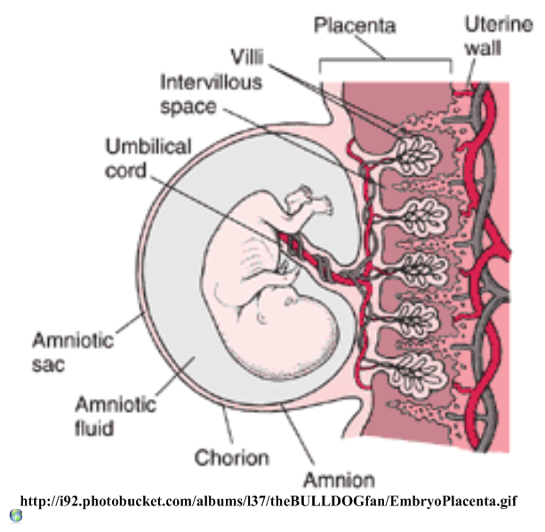
Identify the hormones released by the placenta.
List the materials exchanged between the fetal and maternal blood.
Mother to fetus:

Fetus to mother:

- Explain how the following structures of the placenta aid its function.
Umbilical cord
Villi
Inter-villus spaces
Blood supply
Membrane
Rough endoplasmic reticulum in cells
Birth is controlled by positive feedback mechanisms in the body, which is in contrast to the negative feedback mechanisms of homeostasis. State the name of the ‘birth hormone’.
- Explain why regulation of this hormone is classed as positive feedback control.

