7.2.A1 The promoter as an example of non-coding DNA with a function.

- Coding regions are used as a guide for the production of polypeptides, but non-coding regions are not. Non-coding regions do however have important functions, for example promoters. Outline how promoter regions of DNA molecules aid the production of polypeptides.

7.2.U5 Gene expression is regulated by proteins that bind to specific base sequences in DNA.

- One well known example of the regulation of gene expression by proteins is the metabolism of lactose in E. Coli (prokaryotic bacteria). The diagram below illustrates this example. Complete the cloze to outline this example of gene expression.
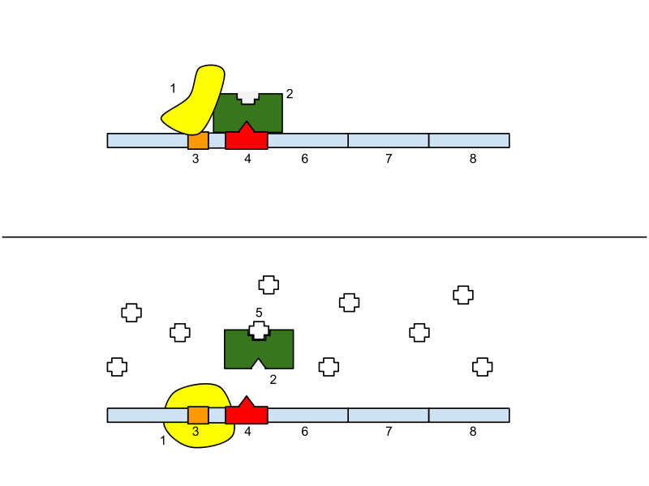  http://commons.wikimedia.org/wiki/File:Lac_Operon.svg | _____________ binds to the operator. _____________ cannot bind to the ___________ therefore the genes that produce proteins involved in lactose metabolism ___________ be transcribed.
 | _____________ binds to the repressor. The _____________ cannot bind to the operator. RNA polymerase binds to the _____________ allowing the genes that produce proteins involved in lactose metabolism ___________ be transcribed.

Key
1 | RNA Polymerase | 4 | Operator
2 | Repressor | 5 | Lactose
3 | Promoter | 6, 7 & 8 | Genes that produce proteins (e.g. enzymes involved in lactose metabolism)

- Complete the table to outline the functions of the different types of gene expression regulation by proteins that occur in eukaryotes.
DNA Sequence | Binding protein | Function
Enhancers | Activator
Silencers
 |  | A region of DNA located close to a specific gene. Once bound to the sequence RNA polymerase transcribes the gene.
7.2.U6 The environment of a cell and of an organism has an impact on gene expression.

- Give an example of how the environment of an organism impacts gene expression.

The environment of a cell can also impact gene expression. This is a complex area of genetics, but can be summarised:

- Only a small number of genes are involved in determining body patterns during embryonic development.
- The expression of these genes is regulated by a group of molecules referred to as morphogens.
- Morphogens diffuse across the surfaces of cells from a concentrated source.
- Embryonic cells get different concentrations of morphogens.
- Morphogens regulate the production of a transcription factors in a cell.
- This results in the activation and inhibition of different genes in different cells.
- This in turn controls how long your fingers should be, where your nose is on your face, and other specifics about body structure.
7.2.U2 Nucleosomes help to regulate transcription in eukaryotes.

- State the name of the key chemical group that can be added to DNA to affect transcription.

- Review your understanding of nucleosomes. Identify which region of histone molecules are exposed and hence may easily be modified and state the names of the key chemical groups that can be added to histones to affect transcription regulation.

- Outline how the modification of DNA and histones can activate or deactivate genes.

- Outline how modification of DNA and histones maybe influenced by environmental factors.

- Suggest how modified DNA or histones maybe inherited by offspring.

- State the name of the branch of genetics concerned with these hertible changes not caused by DNA.

Nature of Science: Looking for patterns, trends and discrepancies - there is mounting evidence that the environment can trigger heritable changes in epigenetic factors. (3.1)

- Use the Learn.genetics resources (http://learn.genetics.utah.edu/content/epigenetics/) to identify and outline the evidence that supports the idea that the environment can trigger heritable changes in epigenetic factors.

7.2.S1 Analysis of changes in the DNA methylation patterns.

- The images show a mapping of chromosomal regions with differential DNA methylation in monozygotic (identical) twins. The numbers below each chromosome indicate which four chromosomes, from the twenty three pairs that humans possess, are being analysed. The diagrams maps changes between the twins’ levels of methylation of DNA across the chromosomes.
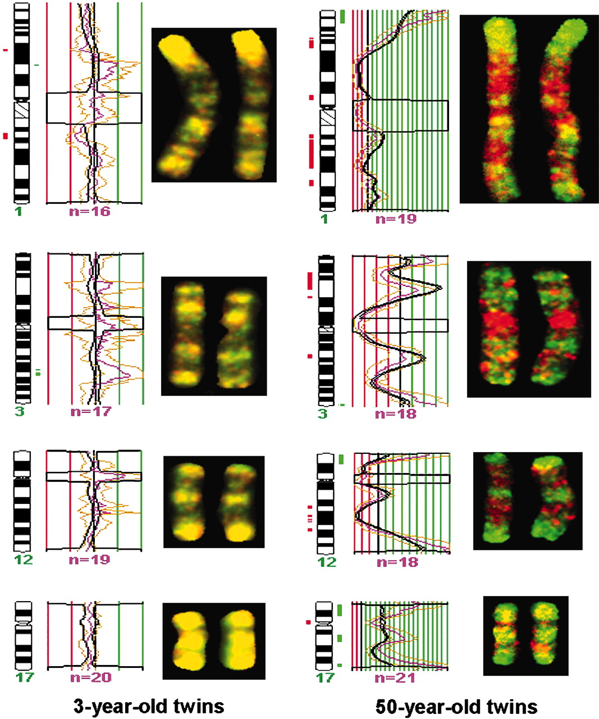 | Green indicates Hypermethylation  (high levels of methylation) in one twin compared to the other.  Yellow shows similar levels of methylation in both twins.  Red shows Hypomethylation  (low levels of methylation) in one twin compared to the other.
http://www.pnas.org/content/102/30/10604/F3.expansion.html

  - Compare the diagrams (not the graphs) and summarise the evidence.

  - Analyse the evidence and deduce conclusions that can be made using DNA methylation.

7.2.U1 Transcription occurs in a 5’ to 3’ direction.

- State the direction of transcription and draw a simple diagram to show the addition of an RNA molecule to a growing mRNA strand.

7.2.U3 Eukaryotic cells modify mRNA after transcription.

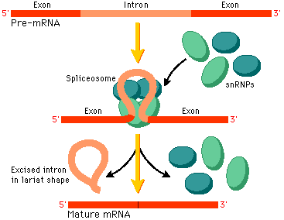
http://www.phschool.com
- Distinguish between introns and exons in eukaryotic DNA.

- Complete the table to outline the process of mature mRNA formation.

Spliceosome | - causes the intron to form a loop
Introns
Mature mRNA | - contains only exons

7.2.U4 Splicing of mRNA increases the number of different proteins an organism can produce.

- The splicing process above can happen in different ways to the same gene.
  - Describe how this happens.

  - What are the implications for the protein expressed by genes that are alternatively spliced.

  - Name an example of a protein family that is commonly alternatively spliced.

Nature of Science: Looking for patterns, trends and discrepancies - there is mounting evidence that the environment can trigger heritable changes in epigenetic factors. (3.1)

- DNA and Genetics is fast evolving area of Biological research. One of the very interesting areas of current research is Epigenetics. Read the article about Epigenetics on Learn.Genetics (http://learn.genetics.utah.edu/content/epigenetics/).
  - Outline what Epigenetics is a study of.

  - Discuss how Epigenetics both fits into the accepted understanding of DNA expression and how is contrary to it.

