7.3.S2 The use of molecular visualization software to analyse the structure of eukaryotic ribosomes and a tRNA molecule.

This understanding requires a review of 2.7.U5. The ability to draw and label ribosomal structure is important for full understanding of the translation process.

- Draw a diagram to outline the structure of a ribosome. Label the following:
  - large subunit
  - small subunit
  - three tRNA binding sites (located on the large subunit)
  - mRNA and the mRNA binding site (located on the small subunit)
  - A growing polypeptide chain

N.B. In some texts ribosomes are shown with two binding sites, the A (aminoacyl) site where tRNA carrying amino acid attach and the P (peptidyl) site where the growing polypeptide is located. The third site, the E (exit) site, is not always regarded as a proper site.

- State what molecules a ribosome consists of.

- Label the following regions on this generalised tRNA molecule, outlining the function of each.

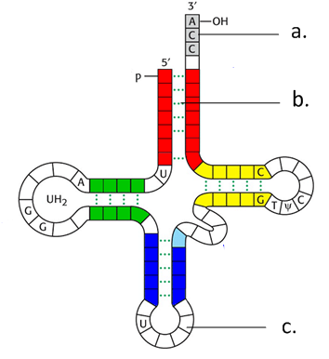 | a.
 |  | function:
 | b. | hydrogen bonds

Nature of Science: Developments in scientific research follow improvements in computing—the use of computers has enabled scientists to make advances in bioinformatics applications such as locating genes within genomes and identifying conserved sequences. (3.7)

- Without computers analysis of the molecular structure such as ribosomal and tRNA structure would not be possible. Bioinformatics also relies on computers to large extent.
  - Outline the field of bioinformatics and what it involves.

  - Explain why computers are a necessity for Scientists working in this field.

7.3.A1 tRNA-activating enzymes illustrate enzyme–substrate specificity and the role of phosphorylation.

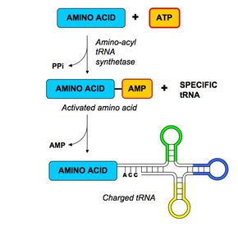
http://www.ib.bioninja.com.au/_Media/trna_activation_med.jpeg
- Explain why there is more than one type of tRNA-activating enzyme.

- Refering to the diagram below outline how tRNA is activated.

7.State the use of the energy transferred to the ‘charged’ tRNA molecule by ATP.

7.3.U1 Initiation of translation involves assembly of the components that carry out the process. AND 7.3.U2 Synthesis of the polypeptide involves a repeated cycle of events. AND 7.3.U3 Disassembly of the components follows termination of translation.
These understandings require a more detailed summary of 2.7.U8. It is recommended, for clarity, that effective diagrams are used to make the steps as clear as possible. More than one diagram maybe used per step if required.

7.3.U6 Translation can occur immediately after transcription in prokaryotes due to the absence of a nuclear membrane.

- State two reasons why translation can occur immediately after transcription in prokaryotes.

- Complete the table to summarise the process of translation.
Stage | Key steps | Diagrams and Notes
Initiation | - mRNA binds to the small subunit of the ribosome.  - The large subunit of the ribosome binds to the tRNA and small subunit | - The mRNA contains a series of codons (3 bases) each of which codes for an amino acid.
Elongation | - A second tRNA (with amino acid attached) complementary to the second codon on the mRNA then binds to the A site of the ribosome  - Another tRNA binds, complementary to the next codon on the mRNA, binds to the A site.  - Steps 6, 7, and 8 are repeated until a stop codon is reached. | - charged tRNA contains energy in the bond with the amino acid attached which will be used to form the peptide bond.  - There are three binding sites on the large subunit of the ribosome, but only two can contain tRNA molecules at a time.
Termination | - When a stop codon is reached translation is stopped:

7.3.S1 Identification of polysomes in electron micrographs of prokaryotes and eukaryotes.

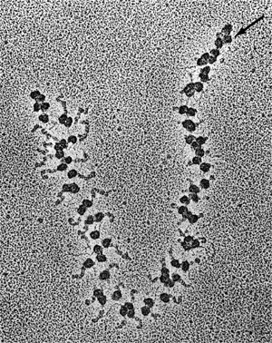
- A polysome is a structure that consists of multiple ribosomes attached to a single mRNA translating it simultaneously to quickly create many copies of the required polypeptide.
  - Label the eukaryote polysome to right to indicate:
    - mRNA
    - Ribosomes
    - Polypeptide chains

  - Describe how polysomes in prokaryotes may differ in structure from polysomes in eukaryotes.

7.3.U7 The sequence and number of amino acids in the polypeptide is the primary structure.
7.3.U8 The secondary structure is the formation of alpha helices and beta pleated sheets stabilized by hydrogen bonding.
7.3.U9 The tertiary structure is the further folding of the polypeptide stabilized by interactions between R groups.
7.3.U10 The quaternary structure exists in proteins with more than one polypeptide chain.
n.b. the next two questions are based on a review of 2.4.U5 and 2.4.U6 and the extension question posed

- Once translated the polypeptide will naturally fold into a structure. The structure is the result of the polar nature of water in the cytoplasm, hydrogen bonds and interactions between the R-groups.
  - The R-groups of an amino acid are classified as having one of a number of different properties. List the properties can they possess.

  - Complete the table to outline the four different levels of protein structure.
 | Notes | Fibrous or Globular
Primary (polypeptide) | - The order / sequence of the amino acids of which the protein is composed  - Formed by covalent peptide bonds between adjacent amino acids  - Controls all subsequent levels of structure | Neither (– will fold to become one of the subsequent levels of structure)
Secondary
Tertiary
Quaternary

