Chapter 10 Review Sheet
10. 1 Meiosis
Vocab: chromatid, chromosome, homologous chromosomes, sister chromatids,
Sources of variation, phase it happens in

Crossing over
Chiasmata

Recombination (recombinants) vs wild type

Independent assortment/ Random orientation
10.2 Genetics and Evolution
Exceptions to Mendel’s rules

Test cross results for dihybrid crosses

Linked gene format and possibilities:
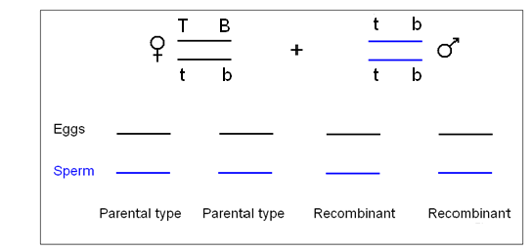
Polygenic traits

Chi square test to determine if traits follow regular Mendel rules, or are linked, or sex linked…
Understanding of expected ratios (9:3:3:1 or punnett square)

10.3 Gene Pools and speciation
Gene pool, allele frequency, speciation

Directional, stabilizing, disruptive frequency change (definition and graphs)

Types of reproductive isolation

Gradualism vs punctuated equilibrium

Polyploidy

Hardy Weinberg
Equations?
What does p mean? What does q mean?
What does p² mean? What does q² mean? What does 2pq mean?

Why do you need to get q² first?

