10.3.U1 A gene pool consists of all the genes and their different alleles, present in an interbreeding population.

- State the definition of the term gene pool.

- Explain what is meant by the term allele frequency.

10.3.U2 Evolution requires that allele frequencies change with time in populations.

- Outline why for evolution to occur a change in allele frequencies, within a population, is necessary.

- Suggest ways in which allele frequency could change. 10.3.A1 Identifying examples of directional, stabilizing and disruptive selection.

- Complete the table giving examples of the different types of selection.
Type of selection | Diagram | Example
 |  | Species | Selective pressure | Result
directional
stabilizing
disruptive

10.3.U3 Reproductive isolation of populations can be temporal, behavioural or geographic.

- State what is meant by the term reproductive isolation.

- Outline the mechanism by which populations can be reproductively isolated giving examples for each mechanism.
  - Temporal isolation

  - Behavioural isolation

  - Geographic isolation
10.3.S1 Comparison of allele frequencies of geographically isolated populations.
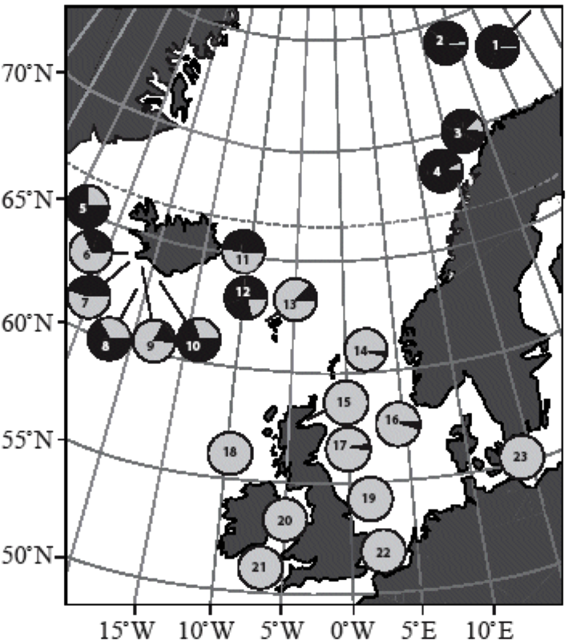
- PanI is a gene in cod fish that codes for an integral membrane protein called pantophysin. Two alleles of the gene, PanI^{A} and PanI^{B}, code for versions of pantophysin. Samples of cod fish were collected from 23 populations in the north Atlantic and tested to find the proportions of the alleles in each population. The proportions of alleles in a population are called the allele frequencies. The frequency can vary from 0.0 to 1.0 with the total frequency of all alleles always being 1.0.
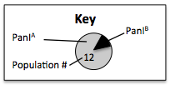

  - State the two populations with the highest PanIB allele frequencies. [1]

  - State the population in which the allele frequencies were closest to 0.5. [1]

  - Deduce the allele frequencies of a population in which half of the cod fish had the genotype PanIA PanIA, and half had the genotype PanIA PanIB. [2]

  - Identify an example of two geographically isolated populations. [1]

  - Give Suggestions why the PanIB allele is more common in population 13 than population 22. [2]

10.3.U4 Speciation due to divergence of isolated populations can be gradual. AND 10.3.U5 Speciation can occur abruptly.
- Complete the table to distinguish between the different rates at which speciation can occur.
Speciation rate | Gradual | Abrupt
Term
Description
Nature of science: Looking for patterns, trends and discrepancies - patterns of chromosome number in some genera can be explained by speciation due to polyploidy. (3.1) AND 10.3.A2 Speciation in the genus Allium by polyploidy.
- Compared to the terms haploid and diploid describe what is meant by the term polyploidy.

- Outline how polyploidy can occur.
- Polyploidy is quite common in plants.
  - Explain why polyploidy is more common in plants than animals.
  - Describe why a polyploid plant can have a selective advantage over diploid rivals.

- Polyploidy can lead to speciation, as individuals with different numbers of chromosomes cannot interbreed. State two examples of different species found in the plant genus Allium and the number of chromosome of each species.

